Lab 3 - Switch interfaces configuration

Lab instructions

This lab will test your ability to configure speed, duplex, and vlan settings on a cisco switch interfaces.

1. Connect to Switch0 using console interface and configure each Switch0 fastethernet switchport for operation. Correct settings are :  
- Port type : access port  
- Speed : 100 Mbit/s  
- Duplex mode : Full Duplex  
- Autonegotiation disabled

2. PC "192.168.1.4" seems to be unable to ping other PCs in the network. Check switch configuration.  
TIP : How many broadcast domains are there in this network ?

3. Choose the right cable to connect :  
- Switch0 gigabitethernet 1/1 to Switch1 gigabitethernet 1/1  
- Switch1 gigabitethernet 1/2 to Switch2 gigabitethernet 1/2

4. Configure those two links as trunk lines without using trunk negotiation between switches

Network diagram

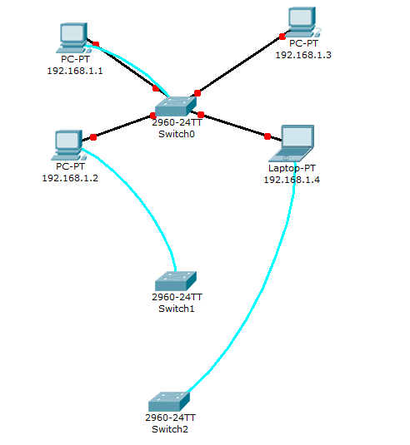

Solution

**Connect to Switch0 using console interface and configure each Switch0 fastethernet switchport for operation.**

Switch(config)#interface FastEthernet0/1

switchport mode access  
duplex full  
speed 100

Switch(config)#interface FastEthernet0/2

switchport mode access  
duplex full  
speed 100

Switch(config)#interface FastEthernet0/3

switchport mode access  
duplex full  
speed 100

Switch(config)#interface FastEthernet0/4

switchport mode access  
duplex full  
speed 100

**PC "192.168.1.4" seems to be unable to ping other PCs in the network. Check switch configuration.**  
Switch(config)#interface FastEthernet0/4

Switch(config-if)#switchport mode access

Switch(config-if)#switchport access vlan 1

**Choose the right cable to connect :**  
**- Switch0 gigabitethernet 1/1 to Switch1 gigabitethernet 1/1  
- Switch1 gigabitethernet 1/2 to Switch2 gigabitethernet 1/2**

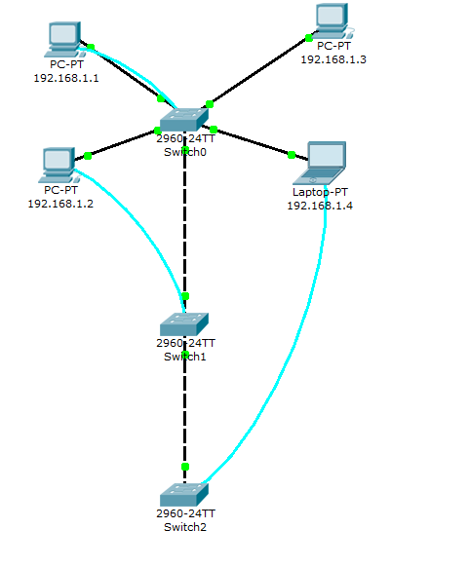

**Configure those two links as trunk lines without using trunk negotiation between switches**

On every interface that has to be configured for trunk operation, configure the following settings

Switch(config)#interface GigabitEthernet1/X

Switch(config-if)#switchport mode trunk

Verify interface operational mode using the "show interface GigabitEthernet1/X switchport command" :

Name: Gig1/2

***Switchport: Enabled***

***Administrative Mode: trunk***

***Operational Mode: trunk***

Administrative Trunking Encapsulation: dot1q

Operational Trunking Encapsulation: dot1q

Negotiation of Trunking: On

Access Mode VLAN: 1 (default)

Trunking Native Mode VLAN: 1 (default)

Voice VLAN: none

Another usefull ios command is "show interfaces trunk" :

Switch#sh interfaces trunk   
Port        Mode         Encapsulation  Status        Native vlan  
Gig1/2      on           802.1q         trunking      1  
  
Port        Vlans allowed on trunk  
Gig1/2      1-1005  
  
Port        Vlans allowed and active in management domain  
Gig1/2      1  
  
Port        Vlans in spanning tree forwarding state and not pruned  
Gig1/2      1